* **Annotation**

@Embeddable

@EmbeddedId or @IdClass

* 1 vài điều kiện cho các primary key field
  + it should be defined using **@EmbeddedId** or **@IdClass** annotations
  + it should be **public**, **serializable** and have a **public no-arg constructor**
  + it should implement **equals()** and **hashCode()** methods
  + Attributes can be basic, composite or ManyToOne, avoiding collections and OneToOne attributes.
* **@EmbeddedId**

VD:

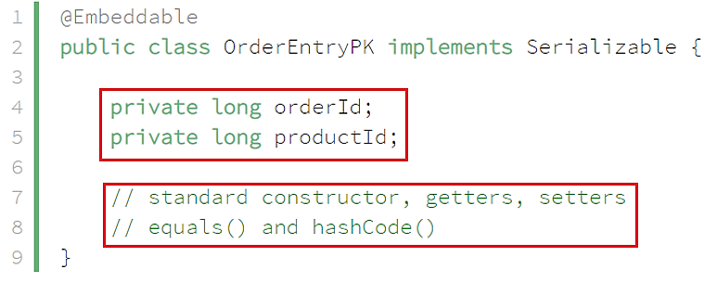

*Define primary key*

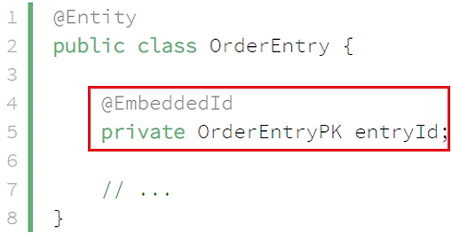

*Config primary key field*

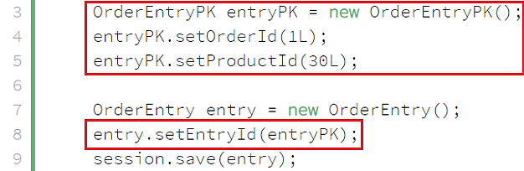

*Using*

* **@IdClass**

the primary key class can also contain @ManyToOne attributes.

VD:



*Define primary key*

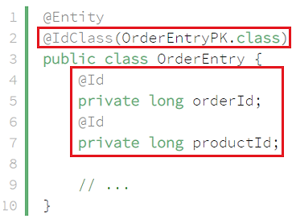

*Config primary key field*

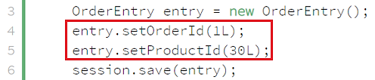

*Using*

* **Reference**

<https://www.baeldung.com/hibernate-identifiers>